Prayer Concerns
Prayer chain requests can be submitted by calling or texting
Pastor Luke’s cell phone

Within our Body:
Priscilla Rowe, Chuck Rowe, Mary Hamilton, Mickie McWilliams,
Kay McWilliams, Bob Murphy, Molly Britton, Jen Hoover,
Sandi Madche

Beyond:
Healthcare workers, Teachers, Staff & Administrators, Government
Officials, Lifewise Academy (Bible Release)

Mission of the Week: MAP (Mission to Amish People), Joe & Esther Keim
Ministry of the Week: Christian Education-Babies, Toddlers, Preschool
Jenn Kestner

**********************************************************************************

Our Staff

Pastoral: Cell phone:

Luke Kelley – Pastor 567-203-2661
Administrative:
Janna Kline – Office Administrator 567-203-9176

Office Hours 9 AM – 2 PM
Pastor Luke Monday, Tuesday, Wednesday
Janna Monday, Tuesday, Wednesday

Last Week: Offering: $6,646 Budget: $4,177 Variance: $2,469
YTD: Offering: $109,625 Budget: $96,069 Variance: $13,556

**********************************************************************************

Serving Today:
Nursery: Jenn Kestner & Abby Leid
King’s Kids: Lisa White & Garrett Searl
Hosts: Doug & Susan Hamman

Next Week:
Nursery: Cindy Krepina & Kathryn Schultz
King’s Kids: Christina Kelley & Emma Britton
Hosts: Mark & Nancy Wisniewski

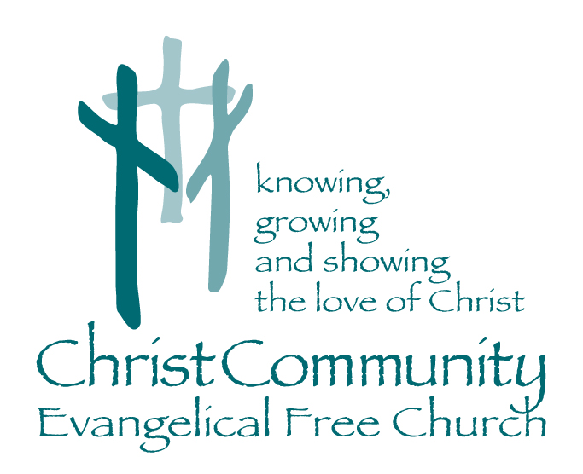

Sunday, June 13th

1272 CR 758, Ashland, Ohio 44805
419-962-4592
Office@Christcommunityefc.org
Christcommunityefc.org

Facebook.com/ChristCommunityEFC
youtube.com/channel/UCUehjxsKdeBtMI2sHAdLrgA/

Welcome to Christ Community Church
10:30 AM Morning Worship

Announcements

Call to Worship
The Lord’s Prayer

Worship with Music
This is Amazing Grace
Days of Elijah
God of Wonders

Prayer & Praise

Special Music
The Company Man
Alex Rowe & Bob Brownson

Worship in the Word
*Children ages 4-7 are invited to King’s Kids for a lesson.

“Meaningless Wisdom”
Ecclesiastes 2:12-17

Song of Response
You Are Holy (Prince of Peace)

Serve—Love Offering June 27
A special offering plate will be set aside on Sunday, June 27th to collect a love offering for Serve. Serve is our local missions trip coming up in August. If you would like to donate to Serve you can do that at anytime, simply designate your giving on your check or envelope towards serve.

Church Picnic—June 27
We will be having a church picnic out in the pavilion after church on June 27. More details coming soon!

Church Softball Game
Save the date! We are planning a church softball game for Sunday, August 1st. This will be a great time of fellowship! Please see Doug Hamman if you have any questions. More details coming soon!

***************************************************************************

Coming Soon…
June 27 Church Picnic after church!
Serve Love Offering
June 28-July 2 2:42 Summer Youth Camp
July 12-16: VBS: “Wilderness Escape”
August 1 Church Softball Game
August 6-7 Serve the Community
August 16 Serve the School

