Prayer Concerns
Prayer chain requests can be submitted by calling or texting
Pastor Luke’s cell phone

Within our Body:
Priscilla Rowe, Chuck Rowe, Mickie McWilliams, Kay McWilliams,
Bob Murphy, Molly Britton, Randy Kline, Jason Robinson,
Glenn Smith, Tim & Marilyn Johnson, Bob Brownson

Beyond:
Healthcare workers, Teachers, Staff & Administrators, Government
Officials, Lifewise Academy (Bible Release)

Mission of the Week: EFCA Reach Global
Ministry of the Week: Christian Education – Adult, Bob Brownson

**********************************************************************************

Our Staff

Pastoral: Cell phone:

Luke Kelley – Pastor 567-203-2661
Administrative:
Janna Kline – Office Administrator 567-203-9176

Office Hours 9 AM – 2 PM
Pastor Luke Monday, Wednesday, Thursday
Janna Monday, Wednesday, Thursday

Last Week: Offering: $2,104 Budget: $4,177 Variance: $-2,073
YTD: Offering: $186,710 Budget: $171,253 Variance: $15,457

**********************************************************************************

Serving Today:
Nursery: Morgan Leid & Jenn Kestner
King’s Kids: Nancy Wisniewski & Danielle Gitto
Hosts: Marvin & Linda Stuart

Next Week:
Nursery: Abby Leid & Cindy Krepina
King’s Kids: Lisa White & Garrett Searl
Hosts: Lorin & Joanie Shriver
Cookie Fellowship Host: Joanie Shriver
Cookie/Snack: Joanie Shriver & Doug & Susan Hamman

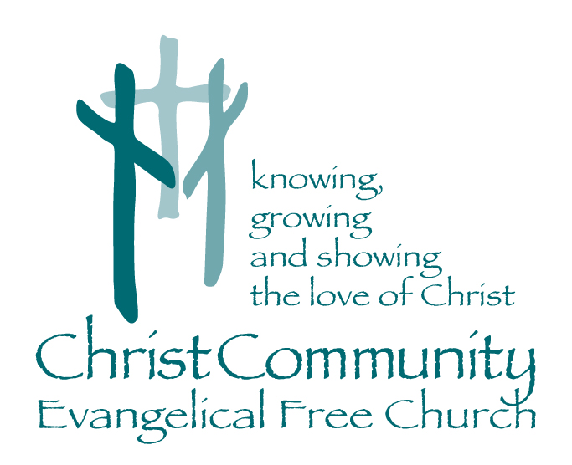

Sunday, October 17th

1272 CR 758, Ashland, Ohio 44805
419-962-4592
Office@Christcommunityefc.org
Christcommunityefc.org

Facebook.com/ChristCommunityEFC
youtube.com/channel/UCUehjxsKdeBtMI2sHAdLrgA/

Welcome to Christ Community Church
10:30 AM Morning Worship

Announcements

Call to Worship
“We’re Here to Worship”

Worship with Music
Shout to the North
We Are
I Love to Tell the Story

Worship Through Giving
Doxology

Prayer & Praise

Worship in the Word
*Children ages 4-7 are invited to King’s Kids for a lesson.

Pictures of the Church:
“Missional People”

Song of Response
Go Light Your World

***************************************************************************

This Week…
Tonight: 2:42 Youth Group 6-8pm
Monday: Elder Board Meeting 7pm
Wednesday: Lighthouse Friends 7pm
Thursday: SERVE Planning Meeting 7pm

Coming Soon…
October 29: 2:42 Youth Bonfire 7pm
October 31: Benevolent Offering
November 7: Annual Meeting

Check Your Mailbox…
Congregational Packets have been placed in all church mailboxes. Please pick up your packet today so you will have a chance to look it over before the Annual Congregational Meeting on Sunday, November, 7th.

Associate Pastor Search
Christ Community EFC is prayerfully searching for an Associate Pastor of Youth Ministry & Missional Outreach.
The position has been posted online at both our website and the EFCA, as well as the following schools: Ashland, Grace, Moody & Trinity.

In addition to finding someone passionate about investing in our youth, we are also looking for someone who can help us grow in reaching our community and living missional lives. Most of all, we are looking for a ministry partner who is passionate about Jesus, God’s people, and working together.

Be in prayer about this process, and please pass along to potential candidates you might know.

