Prayer Concerns
Prayer chain requests can be submitted by calling or texting
Pastor Luke’s cell phone

Within our Body:
Priscilla Rowe, Chuck Rowe, Mickie McWilliams, Bob Murphy,
Tim Johnson, Sandy Poorman, Ellie Grubb, Refresh Remodeling

Beyond:
Healthcare workers, Teachers, Staff & Administrators, Government
Officials, Lifewise Academy (Bible Release), Pro-Life Laws in States

Mission of the Week: Trinity International University
Ministry of the Week: Buildings & Grounds, Bob Frazier

**********************************************************************************

Our Staff

Pastoral: Cell phone:

Luke Kelley – Pastor 567-203-2661
Administrative:
Janna Kline – Office Administrator 567-203-9176

Office Hours 9 AM – 2 PM
Pastor Luke Monday, Wednesday, Thursday
Janna Monday, Wednesday, Thursday

Last Week: Offering: $6,105 Budget: $4,282 Variance: $1,823
YTD: Offering: $167,960 Budget: $158,424 Variance: $9,536

**********************************************************************************

Serving Today:
Nursery: Lisa White & Kathryn Schultz
King’s Kids: Mindy Rowlands & Garrett Searl
Hosts: Patrick & Christine Miller

Next Week:
Nursery: Leah Bechtol & Mira Bechtol
King’s Kids: Nancy Wisniewski & Alyssa Henthorn
Hosts: Marvin & Linda Stuart
Cookie Fellowship Host: Garry & Debbie Bridges
Cookie/Snack: Lisa White

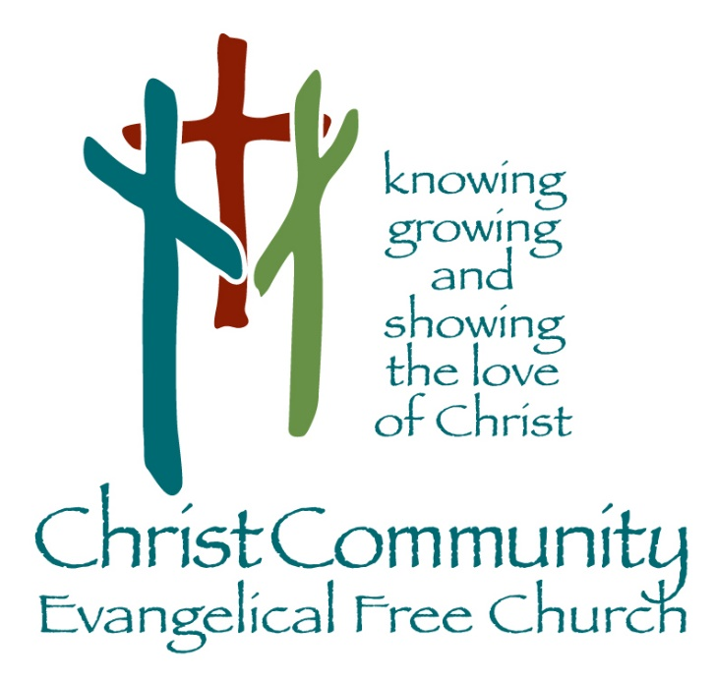

September 18th, 2022

1272 CR 758, Ashland, Ohio 44805
419-962-4592
Office@Christcommunityefc.org
Christcommunityefc.org

Facebook.com/ChristCommunityEFC
youtube.com/channel/UCUehjxsKdeBtMI2sHAdLrgA/
Welcome to Christ Community Church

Announcements

Call to Worship
10 Commandments

Worship Through Song
Sing To The King
Today
Jesus
Worship Through Giving
#382 Doxology

Worship in the Word
Father Abraham Had Many Sins
Genesis 12

*Children ages 4-7 are dismissed to King’s Kids

Song of Response
Lord I Need You

This Week
Today 2:42 Youth, 6-8pm
Wednesday Lighthouse Friends, 6:30pm

Coming Soon
September 26 Elder Board Meeting, 7pm
October 1 Ashland Pregnancy Care Center’s Walk For Life
October 2 Missions Team Meeting after church
October 9 2:42 Taco Bar Fundraiser after church
October 15 Fall Festival, 6pm

Calling ALL Walkers!
Walk for Life & 5K Fun Run
October 1st
Ashland Pregnancy Care Center is hosting their annual Walk for Life & 5K Fun Run on October 1st. You may contact Angela Phelps for more information and to get a pledge sheet. You also may call the Ashland Pregnancy Care Center at 419-281-1111 or go to www.AshlandCareCenter.org/Walk to register. We hope you will plan to participate and show your support for and belief in the value of all human life.

Calendar of Events
SAVE The Following DATES

Missions Team Meeting
Sunday, October 2nd
After church
The Missions Team will have a meeting after church in the Fellowship Hall. The meeting will last around 45 minutes.

2:42 Youth Taco Bar Fundraiser
Sunday, October 9th
After church
Please mark your calendar and plan to stay after church to support our Youth and enjoy some tacos, as well as a great time of fellowship!

Fall Festival
Saturday, October 15th
6pm in the Pavilion
There will be food, a hayride, kettle corn, pumpkins and more.
Watch for more details to come. Put this on your calendar and plan to enjoy a fun time of fellowship for the whole family!

