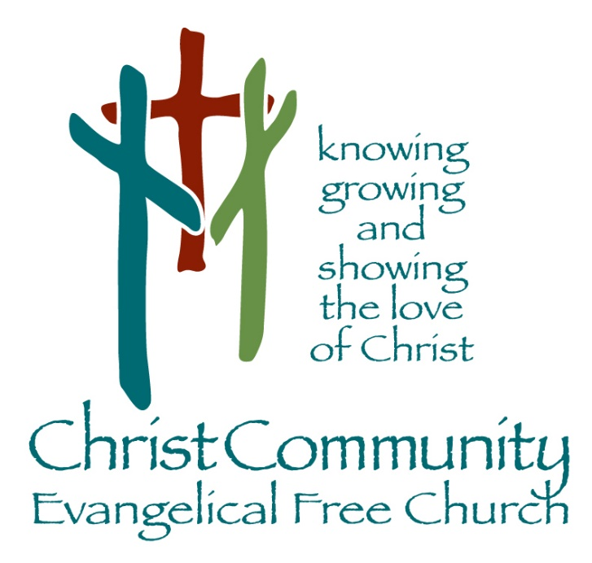

Sunday, May 17th

Sunday Service Times:
Sunday School 9:00 am
Cookie Fellowship 10:00 am
Worship Service: 10:30 am

Christcommunityefc.org
Office@Christcommunityefc.org
Phone: (419) 962-4592
1272 CR 758, Ashland, Ohio 44805



Facebook.com/ChristCommunityEFC


youtube.com/channel/UCUehjxsKdeBtMI2sHAdLrgA/

The best way to stay connected:
Download our Church App
Scan the QR Code with your Mobile Phone

Welcome to Christ Community Church

Graduate Processional

Welcome & Announcements

Worship in Song

All My Ways
My Worth Is Not In What I Own
You Are Holy

Offering

Doxology

Student Promotion

Graduate Testimonies
Morgan Leid
Raiden Martin
Kathryn Schultz

Song of Response
Abide

This Week
Today Graduation & Promotion Sunday!
2:42 Youth Group, 6 – 8 pm

May 18 Elder Board, 7pm

Next Outdoor Service (Carry-in to follow), 10:30 am
Sunday No Sunday School
2:42 Youth Group, 6 – 8 pm
Welcome!
Robert Lessig, Summer Youth Intern
Zane (Michelle, Hannah) Stepp, Pastoral Resident

Coming Soon

May 25 Memorial Day (office closed)

May 31 Volunteer Appreciation Sunday

Jun 01-03 Youth Worship Camp, 9am

June 04 VBS Meeting, ALL Volunteers

June 21 Father’s Day

June 22-26 VBS: An Irish Adventure, 8:30 am – 12pm
https://ccefcvbs.myanswers.com/emerald-crossing/

Prayer Chain Update
A separate distribution group has been created within the app for the Prayer Chain. If you would like to be on the Prayer Chain, please fill out a request or otherwise let Angela know.

Mowers Wanted for 2026 Mowing Season
Keith Kelley is seeking volunteers to mow church grounds. Sign up is on the bulletin board in the education wing. Contact Keith at (419) 651-2938.

Volunteer Appreciation Sunday, May 31st
God has blessed our church family with so many who use their gifts to serve the Lord in our congregation! Let’s recognize these servants and thank God for them!

Youth Worship Camp: June 01 – 03, 2026, 9am – 3pm
A Google Form link was sent out in the CH Meetings app. Please use this form to register your youth if they’re able to attend.

VBS Meeting for ALL Volunteers, June 04th
There will be a VBS Meeting for ALL Volunteers on Thursday, June 4th, 6:30pm, in the Fellowship Hall. If you have any questions, please see Rachel Robinson, or call her at (419)752-6287.

Prayer Concerns
Health Concerns: Eloise Gott, Mike McWilliams, Joyce Wells

Mission Focus

Mission of the Week: EFCA Latin America
Jim & Kay Panaggio

Ministry of the Week: Member Care, Lisa White

Serving Today:

Nursery: Lori Crist & Jada Reynolds
King’s Kids: No King’s Kids
Greeters: Wayne & Lisa White
Cookie Fellowship Host: Marvin & Linda Stuart
Cookie/Snack: Nadya Williams & Christina Kelley

Next Week:

Nursery: No Nursery – Outdoor Service
King’s Kids: No King’s Kids – Outdoor Service
Greeters: All Attending
Cookie Fellowship Host: All Attending
Cookie/Snack: All Attending

Our Staff

Pastoral: Cell phone:

Luke Kelley – Pastor 567-203-2661

Support:
Angela Phelps – Secretary 419-610-9374
Morgan Leid – Custodial
Office Hours 9 AM – 4 PM

Pastor Luke Monday, Wednesday, Thursday
Angela Monday, Wednesday, Thursday

Last Week Offering : $ 4,233 Budget: $ 4,904 Variance : $ -671
2026 YTD Offering : $88,334 Budget: $ 93,176 Variance : $-4,842

