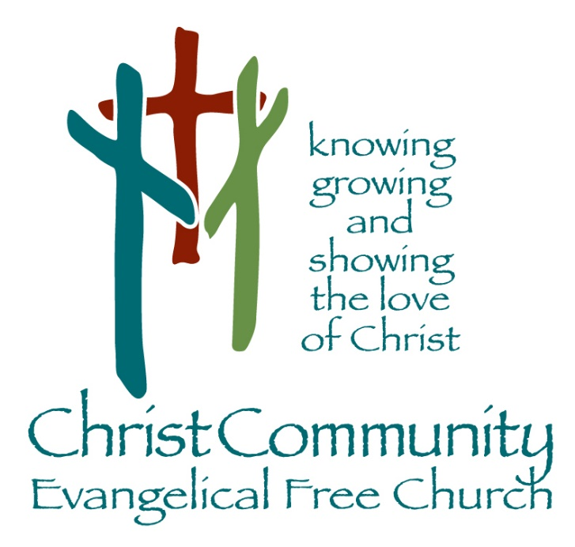

Sunday, June 14th

Sunday Service Times:
Sunday School 9:00 am
Cookie Fellowship 10:00 am
Worship Service: 10:30 am

Christcommunityefc.org
Office@Christcommunityefc.org
Phone: (419) 962-4592
1272 CR 758, Ashland, Ohio 44805



Facebook.com/ChristCommunityEFC


youtube.com/channel/UCUehjxsKdeBtMI2sHAdLrgA/

The best way to stay connected:
Download our Church App
Scan the QR Code with your Mobile Phone

Welcome to Christ Community Church

Welcome & Prayer

Worship in Song

Graves into Gardens

Scripture Reading

Matthew 7:24-27

Worship in Song

In Christ Alone
Cornerstone

Worship through Giving

Doxology

Announcements

Worship in the Word

“You Put My Tears in Your Bottle”
Psalm 56
Pastor Luke Kelley

*Children ages 4-7 are dismissed into the lobby for King’s Kids

Song of Response

Build My Life

This Week

Today 2:42 Youth Group, 6 – 8 pm
Monday Elder Board, 7pm
Tuesday Encore Meeting at Linda & Marvin Stuart’s, 12pm

Coming Soon

Next Sunday Father’s Day – No Youth Group
June 22-26 VBS: An Irish Adventure, 8:30 am – 12pm
https://ccefcvbs.myanswers.com/emerald-crossing/

June 26 VBS Closing Program & All Church Ice Cream Social
June 28 Love offering for SERVE

Mowers Needed for 2026 Mowing Season
Keith Kelley is seeking volunteers to mow church grounds. Sign up is on the bulletin board at the entrance of the education wing. Contact Keith Kelley at (419) 651-2938 with questions or to serve in the Building & Grounds ministry!

Peter & Deb Bors, Knee Surgery Update
Please keep Peter and Deb Bors in your prayers. Deb’s first knee surgery was a success. Read updates and share prayers and notes of encouragement online at https://the-bors-sent2send.epistle.org/ .

Encore Meeting at The Stuart’s Home, June 16th, 12pm
Encore Picnic at Linda & Marvin Stuart’s - Rain or Shine! Located at: 2520 Crum Road, Shiloh, Ohio, 44878. Call Linda Stuart at (567) 203-3139 to RSVP or with questions.

Leadership Transitions
Glenn Smith has resigned as Church Treasurer and Elder. We are grateful for the many years he has served our congregation in these key roles! Lisa White has assumed the position of Treasurer, which leaves open the position of Assistant Treasurer. If you are willing to serve in this area, please talk with Lisa or Pastor Luke.

Prayer Concerns

Health Concerns: Deb Bors, Debbie Bridges, Eloise Gott, Mike McWilliams, Joyce Wells

Mission Focus

Mission of the Week: Joy of Living Ministries, Jeff Egolf
Ministry of the Week: Vacation Bible School, Rachel Robinson

Serving Today:

Nursery: Lisa White & Jenn Kestner
King’s Kids: Christina Kelley & Joanie Shriver
Greeters: Karen Hendricks & Sharon Fahle
Cookie Fellowship Host: Keith & Deb Kelley
Cookie/Snack: Deb Kelley & Bev Gray

Next Week:

Nursery: Nadya Williams & Nancy Wisniewski
King’s Kids: Mindy & Fin Rowlands
Greeters: Karen Hendricks & Sharon Fahle
Cookie Fellowship Host: Gary & Annette Miller
Cookie/Snack: Annette Miller & Jenn Kestner

Our Staff

Pastoral: Cell phone:

Luke Kelley – Lead Pastor 567-203-2661

Zane Step – Pastoral Resident 419-606-6910

Robert Lessig – Summer Ministry Intern 419-685-7395

Support:
Angela Phelps – Secretary 419-610-9374
Morgan Leid – Custodial
Office Hours 9 AM – 4 PM

Pastor Luke Monday, Wednesday, Thursday
Angela Monday, Wednesday, Thursday

Last Week Offering : $ 4,379 Budget: $ 4,904 Variance : $ -525
2026 YTD Offering : $107,504 Budget: $ 112,792 Variance : $-5,288

