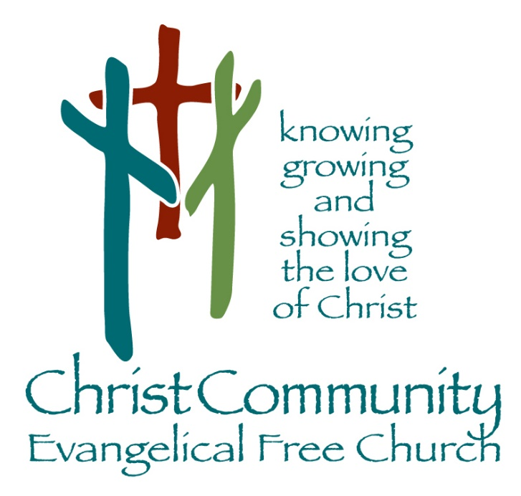

Sunday, June 7th

Sunday Service Times:
Sunday School 9:00 am
Cookie Fellowship 10:00 am
Worship Service: 10:30 am

Christcommunityefc.org
Office@Christcommunityefc.org
Phone: (419) 962-4592
1272 CR 758, Ashland, Ohio 44805



Facebook.com/ChristCommunityEFC


youtube.com/channel/UCUehjxsKdeBtMI2sHAdLrgA/

The best way to stay connected:
Download our Church App
Scan the QR Code with your Mobile Phone

Welcome to Christ Community Church

Welcome & Announcements

Worship in Song

This I Know

Scripture Reading

Isa 40:12-13 & 61:1-3

Worship in Song

Worthy of It All

Worship through Giving

Doxology

Special Music

On My Side

Worship in the Word

Pastor Luke Kelley

Song of Response

Thank You Jesus

This Week

Today Communion
2:42 Youth Group, 6 – 8 pm

Jun 11 Ignite Youth
Coming Soon

Next Sunday 2:42 Youth Group, 6 – 8 pm

June 15 Elder Board, 7pm

June 16 Encore Meeting at Linda & Marvin Stuart’s, 12pm

June 21 Father’s Day

June 22-26 VBS: An Irish Adventure, 8:30 am – 12pm
https://ccefcvbs.myanswers.com/emerald-crossing/

Mowers Needed for 2026 Mowing Season
Keith Kelley is seeking volunteers to mow church grounds. Sign up is on the bulletin board at the entrance of the education wing. Contact Keith Kelley at (419) 651-2938 with questions or to serve in the Building & Grounds ministry!

Peter & Deb Bors, Knee Surgery Update
Please keep Peter and Deb Bors in your prayers. Deb’s knee surgery was a success, though she’s experiencing significant stiffness and pain. You can read updates online at https://the-bors-sent2send.epistle.org/ . There’s also an option on the webpage for posting a note or prayer for encouragement.

Encore Meeting at The Stuart’s Home, June 16th, 12pm
Encore Picnic at Linda & Marvin Stuart’s - Rain or Shine! Located at: 2520 Crum Road, Shiloh, Ohio, 44878. Call Linda Stuart at (567) 203-3139 to RSVP or with questions.

Prayer Concerns

Health Concerns: Deb Bors, Debbie Bridges, Eloise Gott, Mike McWilliams, Joyce Wells

Mission Focus

Mission of the Week: Fostering Families Ministry
Paul Keck & Angela Phelps

Ministry of the Week: Worship & Celebration
Ryan Sedletzech

Serving Today:

Nursery: Sarah Schritz
King’s Kids: Amy Hackney & Kathryn Schultz
Greeters: Patrick & Christine Miller
Cookie Fellowship Host: Paul & Rhonda Keck
Cookie/Snack: Rhonda Keck & Gini Brownson

Next Week:

Nursery: Lisa White & Jenn Kestner
King’s Kids: Christina Kelley & Joanie Shriver
Greeters: Karen Hendricks & Sharon Fahle
Cookie Fellowship Host: Keith & Deb Kelley
Cookie/Snack: Deb Kelley & Bev Gray

Our Staff

Pastoral: Cell phone:

Luke Kelley – Lead Pastor 567-203-2661

Support:
Angela Phelps – Secretary 419-610-9374
Morgan Leid – Custodial
Office Hours 9 AM – 4 PM

Pastor Luke Monday, Wednesday, Thursday
Angela Monday, Wednesday, Thursday

Last Week Offering : $ 6,131 Budget: $ 4,904 Variance : $ 1,227
2026 YTD Offering : $103,124 Budget: $ 107,888 Variance : $-4,764

