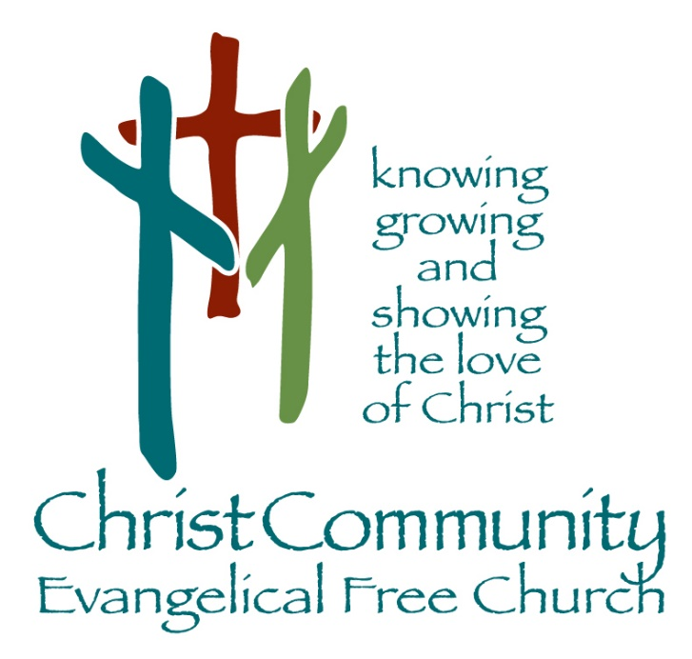

Sunday, May 31st

Sunday Service Times:
Sunday School 9:00 am
Cookie Fellowship 10:00 am
Worship Service: 10:30 am

Christcommunityefc.org
Office@Christcommunityefc.org
Phone: (419) 962-4592
1272 CR 758, Ashland, Ohio 44805



Facebook.com/ChristCommunityEFC


youtube.com/channel/UCUehjxsKdeBtMI2sHAdLrgA/

The best way to stay connected:
Download our Church App
Scan the QR Code with your Mobile Phone

Welcome to Christ Community Church

Welcome & Announcements

Worship in Song

My Life is In You Lord

Scripture Reading

1 Peter 1:3-12

Worship in Song

The Church’s One Foundation
Cornerstone
Christ Our Hope in Life and Death

Worship through Giving

Doxology

Volunteer Appreciation

Worship in the Word

“A Holy & Royal Priesthood”
1 Peter 2:4-9
Pastor Luke Kelley

Song of Response

Yet Not I But Through Christ in Me

This Week

Today Welcome, Robert Lessig, CCEFC Summer Intern!
New Adult Sunday School Classes Began Today!
Church Education Committee Meeting after Service
2:42 Youth Group, 6 – 8 pm

Jun 1 Elder Board, 7pm

Jun 1-3 Youth Worship Camp, M-W, 9am

Jun 4 VBS Meeting for ALL Volunteers, 6:30pm

Coming Soon

Next Sunday Communion

June 16 Encore Meeting at Linda & Marvin Stuart’s, 12pm

June 21 Father’s Day

June 22-26 VBS: An Irish Adventure, 8:30 am – 12pm
https://ccefcvbs.myanswers.com/emerald-crossing/

Peter & Deb Bors, Prayer Request
Deb met with a surgeon at the VA Hospital in Asheville, NC, and is scheduled for replacement surgery for both her knees. Her journey begins with the right knee. Please keep Peter and Deb in your prayers. Read their update and send an online encouragement at https://digest.epistle.org/db0c81ed-dec1-45f7-86cd-f57234b037c4 .

Church Education Committee Meeting, Today, After Service
The church education committee will meet immediately after Sunday morning service. If you’re interested in learning more about this ministry team, contact Dan Williams.

New! Adult Sunday School Classes started Today
Ron Kestner began a new adult Sunday school class today, “Lesser-Known Characters of the Bible”. This class runs through August 30, 2026.

Youth Worship Camp: June 01 – 03, 2026, 9am – 3pm
A Google Form link was sent out in the CH Meetings app. Please use that form to register your youth if they’re able to attend.

VBS Meeting for ALL Volunteers, June 04th
There will be a VBS Meeting for ALL Volunteers on Thursday, June 4th, 6:30pm, in the Fellowship Hall. If you have any questions, please see Rachel Robinson or call her at (419) 752-6287.

Encore Meeting at The Stuart’s Home, June 16th, 12pm
Encore Picnic at Linda & Marvin Stuart’s - Rain or Shine! Located at: 2520 Crum Road, Shiloh, Ohio, 44878. Call Linda Stuart at (567) 203-3139 to RSVP or with questions.

Prayer Concerns

Health Concerns: Eloise Gott, Mike McWilliams, Joyce Wells

Mission Focus

Mission of the Week: Child Evangelism Fellowship
Dale Baer

Ministry of the Week: Greeters

Serving Today:

Nursery: Amy & Maddie Leidigh
King’s Kids: Nady Williams & Linda Stuart
Greeters: Patrick & Christine Miller
Cookie Fellowship Host: Garry & Debbie Bridges
Cookie/Snack: Garry & Debbie Bridges; Susan Hamman

Next Week:

Nursery: Sarah Schritz
King’s Kids: Amy Hackney & Kathryn Schultz
Greeters: Patrick & Christine Miller
Cookie Fellowship Host: Paul & Rhonda Keck
Cookie/Snack: Rhonda Keck & Gini Brownson

Our Staff

Pastoral: Cell phone:

Luke Kelley – Pastor 567-203-2661

Support:
Angela Phelps – Secretary 419-610-9374
Morgan Leid – Custodial
Office Hours 9 AM – 4 PM

Pastor Luke Monday, Wednesday, Thursday
Angela Monday, Wednesday, Thursday

Last Week Offering : $ - Budget: $ 4,904 Variance : $ -
2026 YTD Offering : $ - Budget: $ 94,187 Variance : $ -

