Order of Service

Welcome & Prayer

Worship in Song

God is For Us
To God Be the Glory
Savior, Like a Shepherd Lead Us

Worship through Giving

Announcements

Ministry Highlight: Reach Global

Worship in Prayer

Worship in the Word

“Growing in Stewardship”
Pastor Luke Kelley

*Children ages 4-7 are dismissed into the lobby for King’s Kids

Song of Response

What a Friend We Have in Jesus

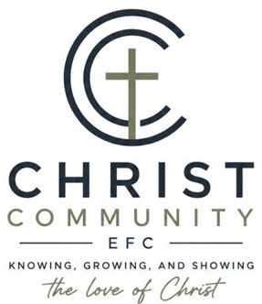

Sunday, October 11th

Sunday Service Times:
Sunday School 9:00 am
Cookie Fellowship 10:00 am
Worship Service: 10:30 am

Christcommunityefc.org
Office.CCEFC@gmail.com
Phone: (419) 908-4006
1272 CR 758, Ashland, Ohio 44805


facebook.com/ChristCommunityEFC


https://www.youtube.com/@ccefc156


The best way to stay connected:
Download our Church App
Scan the QR Code with your Mobile Phone

ANNOUNCEMENTS


Fall Festival – 10/17, 5-8pm
Bring a lawn chair and a soup to share. Invite your friends and family! This is a great time to connect with others in our church family and in our community!


2:42 Nacho Bar – 10/18
Support our youth next week after the service and enjoy a delicious meal and encouraging fellowship! All proceeds benefit youth ministries!

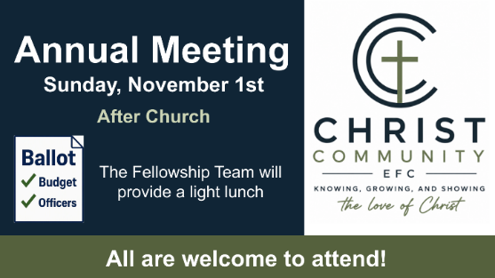

Annual Meeting – 11/1, after church
We invite everyone to participate in our annual meeting. This is an excellent opportunity to hear more about what the Lord is doing at CCC.

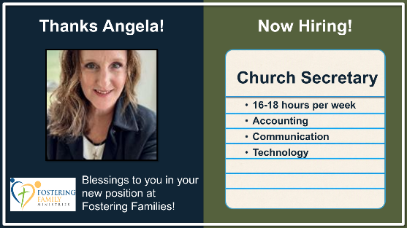
Now Hiring: Church Secretary
Primary responsibilities include: communication technologies, office management, purchasing, and accounting. 16-18 hours per week.
Congratulations, Angela on your new position with Fostering Families! Thanks for your ministry to us!

THIS WEEK

Today Williams Small Group, 1-3pm
2:42 Youth Group, 6-8pm

Tuesday Stepp Small Group, 6-8pm

Saturday Fall Festival, 5-8pm

Next Sunday 2:42 Nacho Bar Fundraiser, after worship service

COMING SOON

October 25 Youth Sunday
November 1 Annual Meeting
November 18 Lighthouse Friends “Friendsgiving” 6:30-8pm

OUR STAFF

Pastoral Phone
Luke Kelley – Lead Pastor (567) 203-2661
Zane Stepp – Pastoral Resident (419) 606-6910

Support
Angela Phelps – Secretary 419-908-4006
Morgan Leid – Custodian
OFFICE HOURS 9 AM – 3 PM

Pastor Luke Wednesday, Thursday
Zane Stepp Wednesday, Thursday
Angela Monday, Thursday

STEWARDSHIP

Last Week Offering: $ 5786 Budget: $ 4904 Variance: $ 882
2026 YTD Offering: $ 188,328 Budget: $ 196,782 Variance: $ -7832

