Order of Service

Welcome & Announcements

Pastor Appreciation

Worship in Song

It Was Finished Upon That Cross
In Christ Alone
Wonderful, Merciful Savior

Worship through Giving

Worship in Prayer

Worship in the Word

“Showing the Love of Christ: Forgiveness”
Matthew 18:21-35
Pastor Luke Kelley

*Children ages 4-7 are dismissed into the lobby for King’s Kids

Song of Response

Yet Not I, But Through Christ In Me

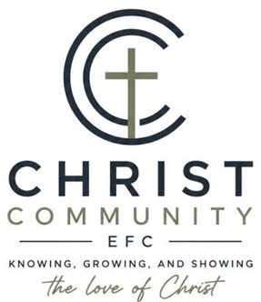

Sunday, October 18th

Sunday Service Times:
Sunday School 9:00 am
Cookie Fellowship 10:00 am
Worship Service: 10:30 am

Christcommunityefc.org
Office.CCEFC@gmail.com
Phone: (419) 908-4006
1272 CR 758, Ashland, Ohio 44805


facebook.com/ChristCommunityEFC


https://www.youtube.com/@ccefc156


The best way to stay connected:
Download our Church App
Scan the QR Code with your Mobile Phone


ANNOUNCEMENTS

2:42 Nacho Bar – TODAY!!
Support our youth next week after the service and enjoy a delicious meal and encouraging fellowship! All proceeds benefit youth ministries!
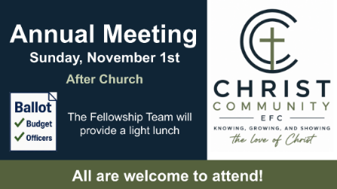
Annual Meeting – 11/1, after church
We invite everyone to participate in our annual meeting. This is an excellent opportunity to hear more about what the Lord is doing at CCC.

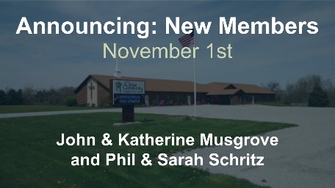
New Members – 11/1
We will be welcoming new members
John & Katherine Musgrove and
Phil & Sarah Schritz.

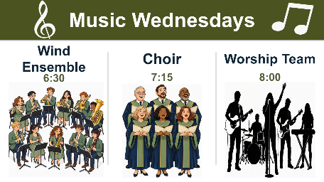
Music Wednesdays
Music Groups will begin rehearsals this week. If you would like to be a part of one of the groups, please let Pastor Luke know.

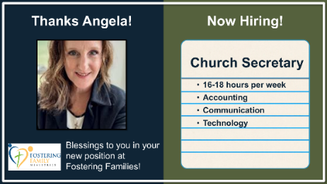
Now Hiring: Church Secretary
Primary responsibilities include: communication technologies, office management, purchasing, and accounting.
16-18 hours per week.
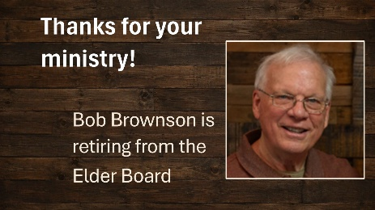

Thanks for your ministry!
Bob Brownson is retiring from the Elder Board. Thank you for your many years of faithful service!
THIS WEEK

Today Williams Small Group, 1-3pm
2:42 Youth Group, 6-8pm

Tuesday Stepp Small Group, 6-8pm

Wednesday Wind Ensemble, 6:30pm
Choir, 7:15pm
Worship Team, 8pm

Next Sunday Youth Sunday

COMING SOON

November 1 Annual Meeting
November 18 Lighthouse Friends “Friendsgiving” 6:30-8pm

OUR STAFF

Pastoral Phone
Luke Kelley – Lead Pastor (567) 203-2661
Zane Stepp – Pastoral Resident (419) 606-6910

Support
Angela Phelps – Secretary 419-908-4006
Morgan Leid – Custodian

OFFICE HOURS 9 AM – 3 PM

Pastor Luke Monday, Wednesday
Zane Stepp Monday, Wednesday
Angela Monday, Wednesday

